Submitting Coursework
Once you've completed the required features for your project, take the following steps to get your project ready to submit.

Steps to submit a project

🎯 Push Code to Github Repository
- If this week's project is starting a new app, you will have to create a new Github repo.
- However, if the week's project is a continuation of the last week's project (E.g. Pair Cards Part 2), you will NOT create a new Github repo and will instead just push your new code.
- Checkout this Submitting Through Github Walkthrough if you're not too familiar with Github yet.

🎯 Create a README Template
- Every submission must be accompanied by a README.md using the readme template provided with the project to demonstrate which required and optional tasks you've completed.
- In your project repository, add a README.md file in the root directory that contains the contents of the README template for that project.
- If the project is a continuation of the same app as the previous week, add the new template to the end of the previous README instead of creating a new file.
- Make sure to check off the user stories you've completed.

🎯 GIF Walkthrough
- Your README.md must contain a GIF walkthrough using a recording program of your choice. It should demonstrating how it works with the user stories completed.
- We recommend using Kap for macOS, ScreenToGif for Windows, and peek for Linux.
- Imgur is a great service for hosting the GIF walkthrough and then linking to it from the README.
- When using Imgur, you can right-click on the gif and choose "Copy Image Address" to get the correct address. Make sure the address has a .gif extension. If you end up with a url that has a .gifv extension, removing the v and changing this to .gif will ensure the gif renders on GitHub.
A GIF / Video of your app is a Requirement for getting credit -- Just screenshots are not enough!

🤔 GIFs not your thing? You can also follow this Video Submission Guide to record and embed a video of your app using Loom!

🎯 Make sure you've pushed all your latest code up to GitHub
- To check this, you can browse your repository on GitHub on your favorite browser to make sure some of your latest changes are present there.

🎯 Make Repository Private & Add CodePath review as collaborator
- Every submission must be submitted in a private repository.
- Check out this Guide on making your repository private.
- Because the repository will be private we must also add the the CodePath review github account as a collaborator.
- Check out this guide on adding the CodePath review github account as a collaborator.

🎯 Submit Project
- Once you have completed all required user stories and added a README as described above go to the Project Tab for the project and click the Submit button on the right-hand side.
- 🏞️ Click for Screenshot
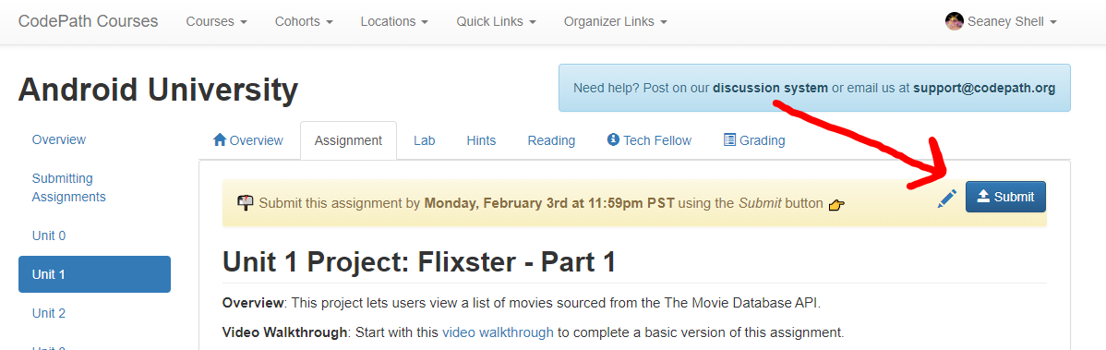
- In the dialog that appears, enter the required information about your project
- 🏞️ Click for Screenshot
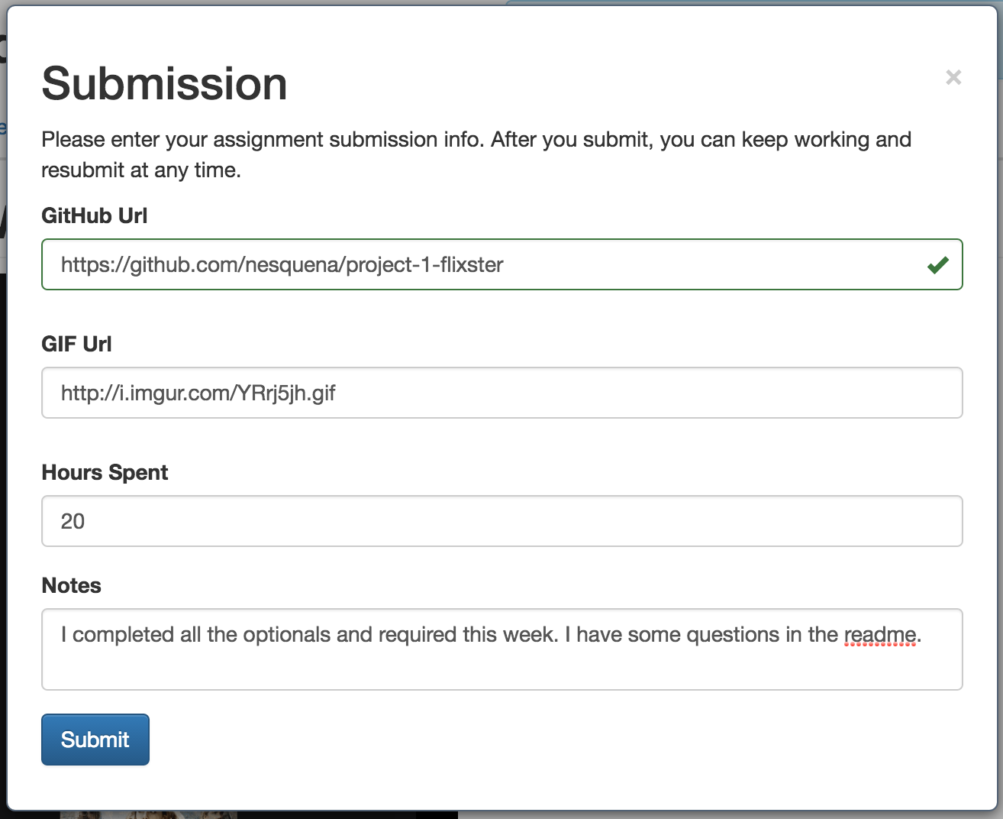
- Then press "Submit" at the bottom to finalize your submission. Note that you can always update your submission at any time in case you want to re-upload the GIF or update the hours spent.
⚠️ NOTE: If you recorded your app walkthrough as a video file instead of a GIF, check out this submission guide for embedding the video into your README.

✅ Ensuring your Submission is Valid
To ensure you get credit for your submission, review the following items:
- Can you see your latest code on GitHub?
- Does your README use the provided readme template?
- Did you include a GIF / Video walkthrough? (NOT only screenshots!)
- When going to your main repository page on GitHub, can you see your README and does your GIF/Video walkthrough start playing?
- Does your app have all of the required features?
Great work! You've submitted your project! 🎉📬🎉

Video submission link: https://www.youtube.com/watch?v=GA92eKlYio4

